**BAYESIAN BELIEF NETWORK QUESTION**

Imagine you live in a neighborhood where there are rare events like burglaries and earthquakes. Your house has an alarm system designed to warn you of these dangers.

1. **The Rare Events**:
   * **Burglary**: Very rare, but it can happen. Think of it as a sneaky burglar trying to get into houses quietly.
   * **Earthquake**: Also rare, but this is nature's doing, shaking the ground unexpectedly.
2. **The Alarm**:
   * This alarm in your house is quite sensitive and smart. It’s connected to sensors that detect both burglaries and earthquakes.
   * If either a burglar breaks in or an earthquake shakes your house, the alarm is likely to go off. It’s more likely to react if both happen at the same time (although that's super rare), but there's a tiny chance it might not trigger if neither occurs.
3. **The Neighbors, David and Sophia**:
   * **David** is a very cautious neighbor. If he hears your alarm, he's very likely to call the police almost immediately, thinking better safe than sorry.
   * **Sophia**, on the other hand, is a bit more relaxed but still vigilant. She calls the police most of the time when she hears the alarm, but not as quickly as David.

**What Happens When the Alarm Sounds**:

* When the alarm goes off, depending on the noise and their personal inclinations, David and Sophia decide whether to call the police. David almost always picks up the phone if he hears the alarm, whereas Sophia might think for a second before deciding.

**Using This Story in Real Life**:

* This setup helps predict how likely it is that a burglary or an earthquake has happened based on whether or not David or Sophia calls. If both call, it’s very likely something serious happened; if neither calls, maybe it was a false alarm.

So, the network helps you understand the probabilities of these events and responses, just like in our story, making it easier to decide how to react or what to expect based on who calls and what the alarm does!

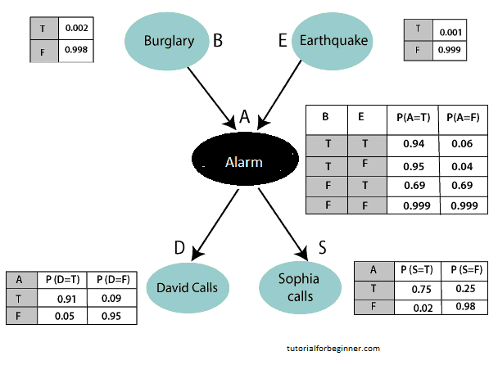

Some questions you could solve using the Bayesian Network you provided:

1. **Here are some straightforward questions to test your understanding of the Bayesian Network described:**
2. **What is the probability of a burglary happening according to the network?**
3. **If the alarm goes off, what are the probabilities that both a burglary and an earthquake have occurred?**
4. **How likely is David to call if the alarm has not gone off?**
5. **What influences Sophia's decision to call the police according to the diagram?**
6. **If the alarm goes off, what is more likely to have happened: a burglary or an earthquake?**